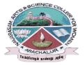
NAVARASAM ARTS AND SCIENCE COLLEGE FOR WOMEN
ARACHALUR, ERODE-638101
STAFF PROFILE
Name | Mrs.S.LATHA
Designation | ASSISTANT PROFESSOR
Qualification | 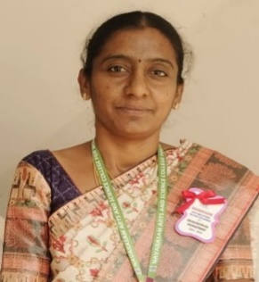  M.Sc.,M.Phil.,
Department | COMPUTER SCIENCE
Phone No. | Office |  | 0424-2357209
 | Mobile |  | 9976664038
Email | 1.latha.686@gmail.com  2. s.latha@ksrcas.edu
Areas of Interest/  Specialization | Networking
Subjects Taught | UG: PG:  1. C 1. BIG DATA ANALYTICS  2. C++ 2. DATA SCIENCE AND ANALYTICS  3. JAVA 3. NETWORK SECURITY & CRYPTOGRAPHY  4. VISUAL BASIC, 4. SOFT COMPUTING  5. GRAPHICS AND MULTIMEDIA, 5. PYTHON PROGRAMMING  6. LINUX, 6. OOAD  7. COMPUTER NETWORKS 7. ADVANCED OPERATING SYSTEM  8. DOT NET PROGRAMMING 8. DATA QUALITY ANALYST  9. DATA STRUCTURES  10. WEB DESIGNING  11. SSOS
Date of Joining in our Institution | 01.10.2021
Experience (in Years) | Industry |  |  | -
 | Teaching |  |  | 17
 | Research |  |  | -
 | Total |  |  | 17
Research Publications in Journals | 4
Papers Published in Conference Proceedings | 6
Books / Chapters  Published | 1
Patent Published | -
Research Projects  Major/ Minor |  | Completed |  |  |  | -
 |  | Undergoing |  |  |  | -
Research Guidance |  | Awarded |  |  |  | Undergoing
 |  | - |  |  |  | -
Conferences |  | Attended |  |  | Presented |  |  | Organized
National |  | - |  |  | 2 |  |  | -
International |  | - |  |  | 2 |  |  | 1
Workshops |  | Attended |  |  |  |  | Organized
 |  | 7 |  |  |  |  | 1
FDP |  | Attended |  |  |  |  | Organized
 |  | 14 |  |  |  |  | 1
Seminar / Webinar |  | Attended |  |  |  |  | Organized
 |  | 43 |  |  |  |  | -
Membership |  | -
Acted as Resource Person |  | -
Awards |  | -
Online Courses |  | Completed |  |  |  |  | Enrolled
 |  | - |  |  |  |  | -
Extension Activities (NSS/YRC) / Club In charge |  | -
Administrative Assignments Handled |  | PLACEMENT CO – ORDINATOR, PROJECT GUIDE, DEPARTMENT CO-ORDINATOR, M.PHIL/PHD CO-ORDINATOR, MENTOR, ACTED AS IQAC CRITERIA-4 MEMBER, WOMENS’S COUNSELOR, NAAN MUDHALVAN CO-ORDINATOR.
Association with Professional Bodies |  | BOARD OF STUDY MEMBER IN KSRCAS, UIVERSITY REPRESENTATIVE FOR THEORY EXAM, EXTERNAL EXAMINER FOR PRACTICALS.
Any other Achievements |  | -
Orchid / Google Scholar/  Research ID |  | -

